Calculator Assumed
Topic: Arc Length and Sector Areas

Time: 45 minutes
Total Marks: 45
Your Score: / 45



Question One: [2, 3, 3 = 8 marks]

Calculate the perimeter of each of the following shapes, giving your answers as exact values.

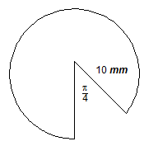

Question Two: [5 marks]

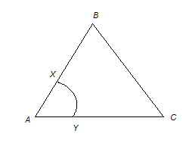
The triangle shown is an equilateral triangle of side length 8 cm, with an arc XY with centre A.

AX:XB is in the ratio 1:3
AY:YC is in the ratio 1:3

Calculate the area of the section enclosed by XBCY.

Question Three: [3 marks]

A sector has a perimeter of .
Determine the angle at the centre of the arc if the radius is 6 cm.

Question Four: [4 marks]

The following image shows four quarter-circle arcs joined together. Each arc has a radius of 7 cm.

Calculate the area of the shape pictured.

Question Five: [2, 1 = 3 marks]

If the arc length of a sector with a central angle of 1 radian is 4 cm, determine:

- the radius of the sector.

- the perimeter of the sector.

Question Six: [2, 2, 3, 3 = 10 marks]

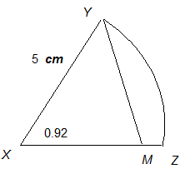
The figure shown is such that
The angle at the center of the sector, , is 0.92 radians.

Calculate:

- The length of arc YZ.

- The area of the sector XYZ.

- The length, XM.

- The area of YMZ.

Question Seven: [4, 1, 2, 3, 2 = 12 marks]
The given diagram shows the design for a student classroom desk.

Calculate:

- the area of the triangular section.

- the angle at the centre of the sector, in radians.

- the length of the arc.

- the area of the segment.

- the perimeter when three desks have been joined together.

SOLUTIONS
Calculator Assumed
Topic: Arc Length and Sector Areas

Time: 45 minutes
Total Marks: 45
Your Score: / 45



Question One: [2, 3, 3 = 8 marks]

Calculate the perimeter of each of the following shapes, giving your answers as exact values.














Question Two: [5 marks]

The triangle shown is an equilateral triangle of side length 8 cm, with an arc XY with centre A.

AX:XB is in the ratio 1:3
AY:YC is in the ratio 1:3

Calculate the area of the section enclosed by XBCY.






Question Three: [3 marks]

A sector has a perimeter of .
Determine the angle at the centre of the arc if the radius is 6 cm.




Question Four: [4 marks]

The following image shows four quarter-circle arcs joined together. Each arc has a radius of 7 cm.

Calculate the area of the shape pictured.







Question Five: [2, 1 = 3 marks]

If the arc length of a sector with a central angle of 1 radian is 4 cm, determine:

- the radius of the sector.




- the perimeter of the sector.



Question Six: [2, 2, 3, 3 = 10 marks]

The figure shown is such that
The angle at the center of the sector, , is 0.92 radians.

Calculate:

- The length of arc YZ.




- The area of the sector XYZ.




- The length, XM.





- The area of YMZ.



Question Seven: [4, 1, 2, 3, 2 = 12 marks]
The given diagram shows the design for a student classroom desk.

Calculate:

- the area of the triangular section.






- the angle at the centre of the sector, in radians.



- the length of the arc.




- the area of the segment.




- the perimeter when three desks have been joined together.



